


PROJECT REPORT
How do investments in fixed capital affect the growth of regional gross product?

Prepared by:
Aruana Sadubayeva,Arlan Toktarkhan,Arys Alpys,Ilyas Okenov
Information systems in business
Submitted to:
Alisher Aldashev

Almaty, 2024-2025
EXECUTIVE SUMMARY
The purpose of this study is to assess the impact of investment in fixed capital on the growth of regional gross product (GRP).In order to objectively assess the need for investment, we calculated the Investment Priority Index (IPI).During the study, this index showed that the largest investment deficit and economic potential is in Atyrau and Karaganda regions. After that, the VAR model was used to analyze the causal relationship between investment in capital and GRP dynamics. According to the results, we found that for Atyrau investments in capital have a significant and stable impact on GRP growth, while in Karaganda there is no direct relationship. It is worth noting that both regions demonstrate pronounced seasonality and trend, which we took into account in the modeling. The main conclusion of our study is that it is inefficient to invest in all regions in the same way. Each region needs its own strategy, which will take into account its peculiarities.

TABLE OF CONTENTS
INTRODUCTION 4
LITERATURE REVIEW 4
DESCRIPTIVE AND GRAPHICAL ANALYSIS 6
STATISTICAL INFERENCE AND FORECASTING 9
CONCLUSION 19
REFERENCES 20

INTRODUCTION
One of the important stimulators of economic growth and development of the country is the correct distribution of investment in fixed capital, which stimulates the modernization of infrastructure, improves living conditions and creates new jobs. In Kazakhstan, these investments play a significant role, as the country faces the task of modernizing infrastructure and expanding industrial facilities to achieve sustainable economic development. Kazakhstan is a large country with different economic conditions in different regions. Some regions may need more production capacity, while others may require investment in infrastructure or the social sphere. Therefore, it is worth noting that it is very important to approach the issue of investment taking into account the specifics of each region. This topic is really interesting, as investments in fixed capital directly affect the future development of the economy and social stability. The study of the need for these investments in the regions of Kazakhstan allows us to evaluate and also draw conclusions about what steps need to be taken for sustainable development. Moreover, this analysis is not limited to historical data only, it includes elements of prediction, which helps to forecast the need for investments in the future. This approach allows us to make informed decisions that will lead to more stable maintenance of economic growth and efficient use of resources in the future. The correct distribution of these investments between the regions of Kazakhstan is a stimulator of economic progress, which will make the country more competitive in the international arena.

LITERATURE REVIEW
In recent years, the relationship between investment in fixed assets and GRP growth has been an important topic for analyzing the development of the economy of Kazakhstan, especially at the regional level. Batisheva (2009) notes that investment processes are an important component in determining the dynamics of capital in the economy and the rate of economic growth. Based on this, the analysis of factors that affect the growth of regional product is very relevant. Rashidov and Rashidova (2010) mentioned about the multiplier effect in their research, referring to Keynesian theory. This means that even a small increase in investment can lead to a significant increase in GRP, which shows the importance of the efficient use of capital investment to stimulate economic growth. Yaparova's research (2022) talks about a high correlation (R-squared = 0.9775) between the volume of investment in the regional economy and the rate of GRP growth, which indicates a positive impact of investment on economic development. Tishchuck and Nazmova (2023) stated that the main driver of economic growth is capital investment in enterprises and organizations, which ensures the development of not only infrastructure, but also the development of technology and innovation. They believe that this contributes to the growth of production, which has the effect of reducing dependence on imports. This plays an important role for the more remote and less developed regions of Kazakhstan. Summarizing their statements, investments create a chain of positive changes, which of course increases GRP. Other researchers, such as Moroshkina and Rozanova (2013) claim that changes in terms of creating new jobs, improving the information structure and modernizing existing industries directly depend on investment, contributing to the growth of GRP. However, according to Korsakova (2022), some instability in the growth rate of investment in different regions of Kazakhstan can slow down economic growth and even lead to stagnation of the economy. This means that the growth rate of GRP may be irregular due to unstable investments. Therefore, it is very important that investments are received evenly and support economic growth.
To sum up, we can claim that all the above-mentioned studies confirm the significant impact of investment in fixed capital on the growth of gross regional product in Kazakhstan, which makes this topic important for study.

DESCRIPTIVE AND GRAPHICAL ANALYSIS
The general representation of demographic and infrastructural conditions is worth detailed visualisation. For convenience in interpretation and predictions for the next 5 years of trends of various regional factors it was decided to use double exponential smoothing, as almost every factor has an obvious trend over 14 years. First and foremost, about the demography of regions, population change plays an important role in the development of regions. The demographic indicator, population, represented by the line graph below, indicates that the three major cities of Kazakhstan will be the leading cities by 2027, with the population of Almaty exceeding 2.5 million people, but population outflows are predicted in regions with large cities such as Turkestan, Almaty and Akmola regions (the prediction for Turkestan region is inaccurate due to the merging of data with South Kazakhstan region).
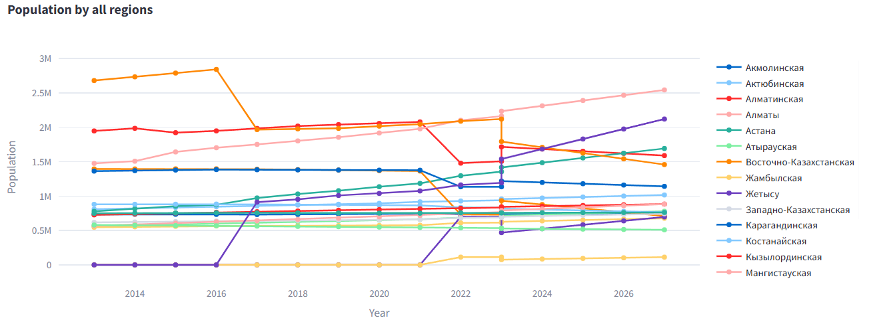
The purpose of our study is to identify regions with promising growth that need more investment in capital. We decided to introduce a variable we call Investment Gap. This is an indicator that shows the difference between investment in fixed capital and the amount of depreciation. The amount of depreciation is calculated according to the formula – $Fixed assets \left(initial value\right)* level of depreciation$. In essence, it is a measure of the net investment gap for each region - the amount needed to fully restore infrastructure. We also used Holt’s linear method and projected the investment gap based on indicators such as population and wages, migration balance, depreciation, and various GRP indicators.
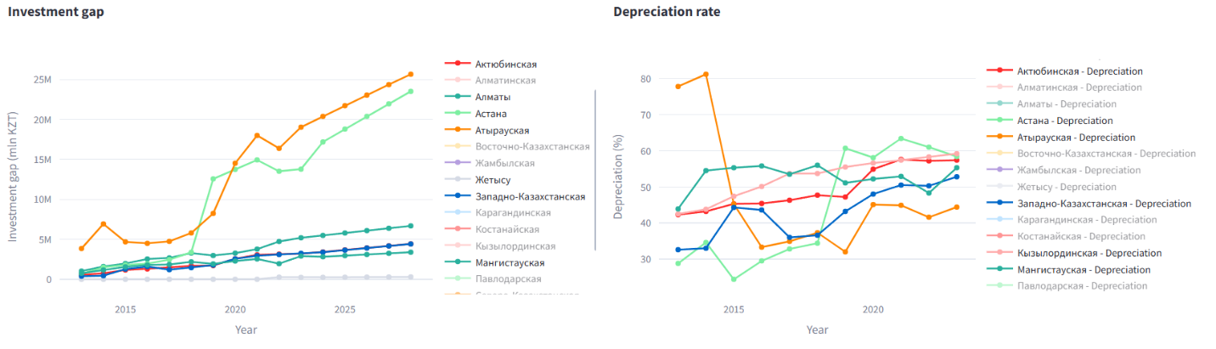
We also decided to calculate an infrastructure need index. This index allows us to assess which regions need more attention in terms of infrastructure. It is calculated based on normalized depreciation, fixed assets, and population of each region with weights of 0.85, 0.1, and 0.05 respectively.
$$INI=0.85*total depreciation+0.1*fixed assets+0.05*population$$
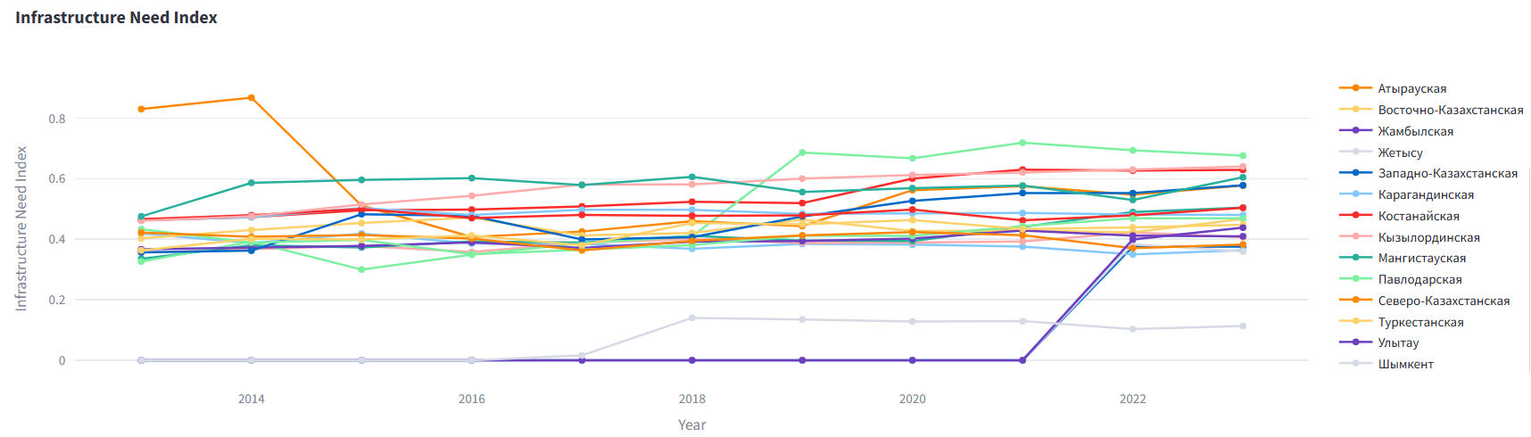
We decided to further experiment with possible metrics for assessing priorities for investment in regional infrastructure. So, we decided to introduce an indicator that we called the Investment Priority Index. It differs from the Infrastructure Needs Index in that it is weighted by a region's share of GDP. Thus, we can assess which regions need more attention in terms of infrast ructure, also being an important component of the economy.
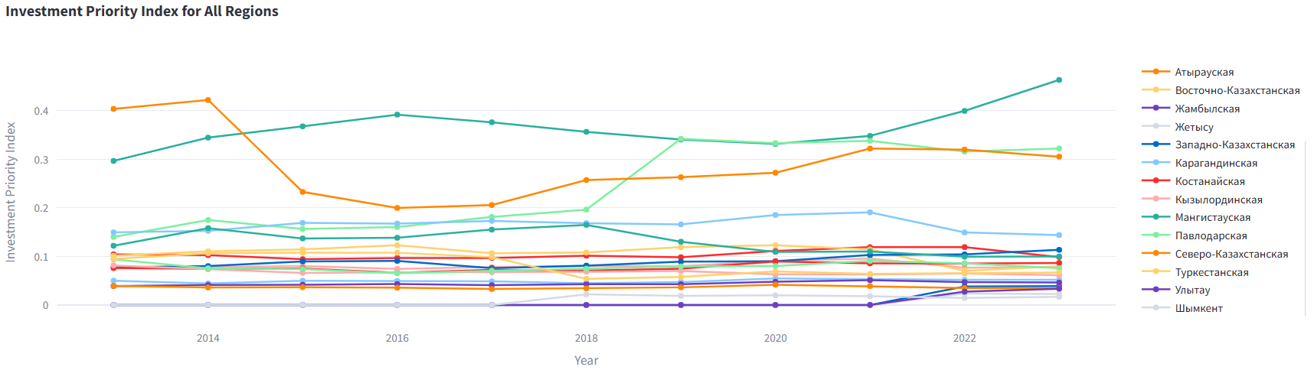
As a result, there is an assumption that the regions of Atyrau and Karaganda are the most important for investment, but there is no evidence yet to state that investment in fixed capital really affects the growth rate of GRP. Therefore, a vector autoregressive model was built to test our hypothesis.
Descriptive statistics for Atyrau region:
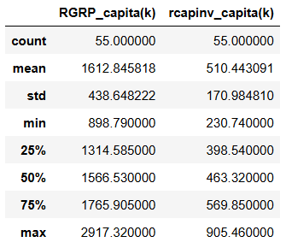
Descriptive statistics for Karagandy region:
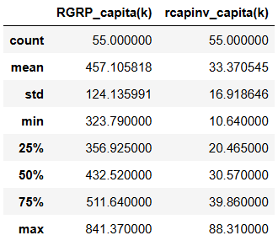
The visualizations were presented in the project on the streamlit platform, which we deployed using the Python programming language. The work is publicly available, but the project is being rolled up within 24 hours, so please notify us when you need to view it. We have attached a link for viewing below.
Link: https://datathondemo-pwgxsyswrz8jz77kpfqjeq.streamlit.app/

STATISTICAL INFERENCE AND FORECASTING
In this section of our study, we will look at how the data about real GRP and capital investment per capita for the years 2011 through 2024 can forecast the regional total output for 5 years (20 quarters) in Kazakhstan’s economically significant regions: Atyrau and Karaganda.
In our investigation, we used the Vector Autoregressive model (VAR).

Model Specification
We estimated the model using data from 55 quarters between 2011 and 2024.
The model is specified as follows:
$y_{t}=δ_{0}+α_{1}y_{t-1}+γ_{1}z_{t-1}+α_{2}y_{t-2}+γ_{2}z_{t-2}+α_{3}y_{t-3}+γ_{3}z_{t-3}+α_{4}y_{t-4}+γ_{4}z_{t-4}+$….
$y_{t}$ – the change of Real GRP per capita (in thousands of tenge) in the t^{th} quarter relative to the t-1 quarter
$z_{t}$ – the change of Real capital investment per capita (in thousands of tenge) in the t^{th} quarter relative to the t-1 quarter
$δ_{0}$– Intercept of the model
$u_{t}$ – Disturbance term
In order to find the optimal lag length for our VAR model, we applied several informational criteria: Akaike Information Criterion (AIC), Hannan-Quinn Criterion (HQ), Schwarz Criterion (SC), and Final Prediction Error (FPE).
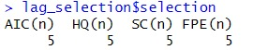
All of them showed that 5 lags should be used.

Analysis of Atyrau
Tests for stationarity and causality in data
We conducted several tests to check our data for causality and stationarity, and whether we can imply VAR or not.
- Granger Causality Test
The Granger Causality Test is a statistical hypothesis test for determining whether one time series is useful in forecasting another.
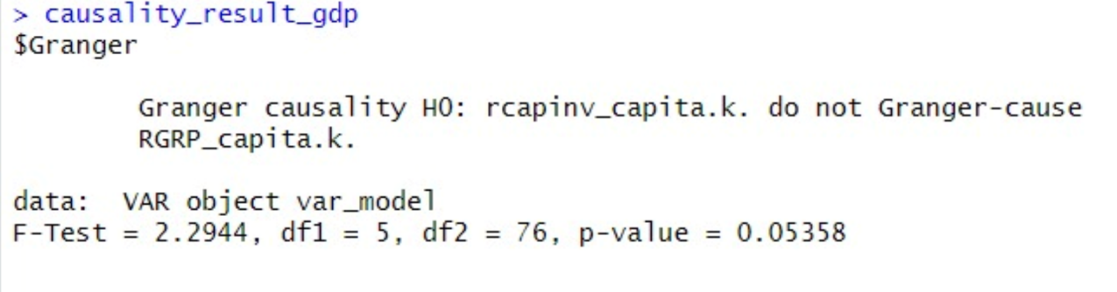
As we can see, the p-value is 0.05358, which is slightly above 0.05. It indicates that we can reject the null hypothesis at a 10% significance level. We have enough statistical evidence that changes in real capital investment and real GRP per capita in the previous quarters predict changes in real GRP per capita in the current quarter.
- Instantaneous Causality Test
The instantaneous causality test looks for an immediate causal link between two variables, or whether there is a relationship between the values of variables throughout the same quarter.
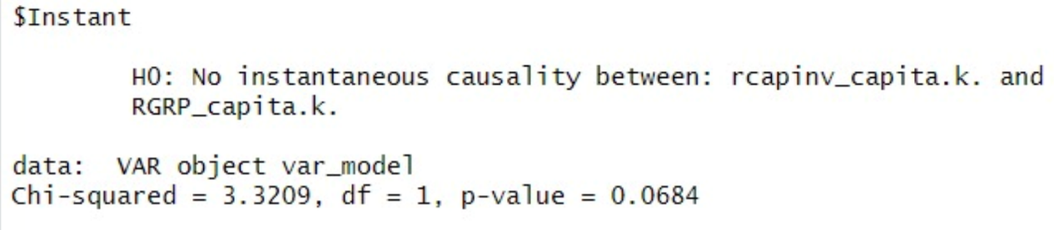
The p-value of 0.0684 indicates that we can reject the H₀ at a 10% significance level. There is instantaneous causality between real capital investment and RGRP per capita.
- Augmented Dickey-Fuller (ADF) Test
The Augmented Dickey-Fuller test is used to determine if a time series has a single root, indicating non-stationarity.

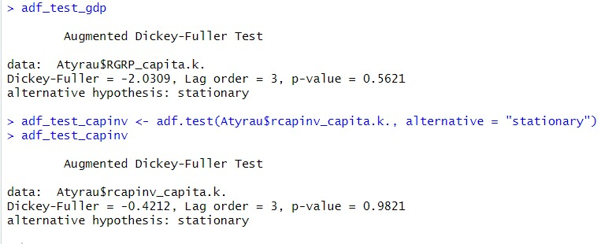
In both cases, we have a problem of non-stationarity, since p-values are very high. As a result, we apply the first difference to both variables to transform them into stationary series. Non-stationarity might be caused by a steady trend and seasonal patterns, even though our variables are adjusted for inflation.
Based on the results of the tests performed, we can say that a VAR framework can be used to model the variables. However, first, we should apply the first difference to our data.

Analysis of Regression Results
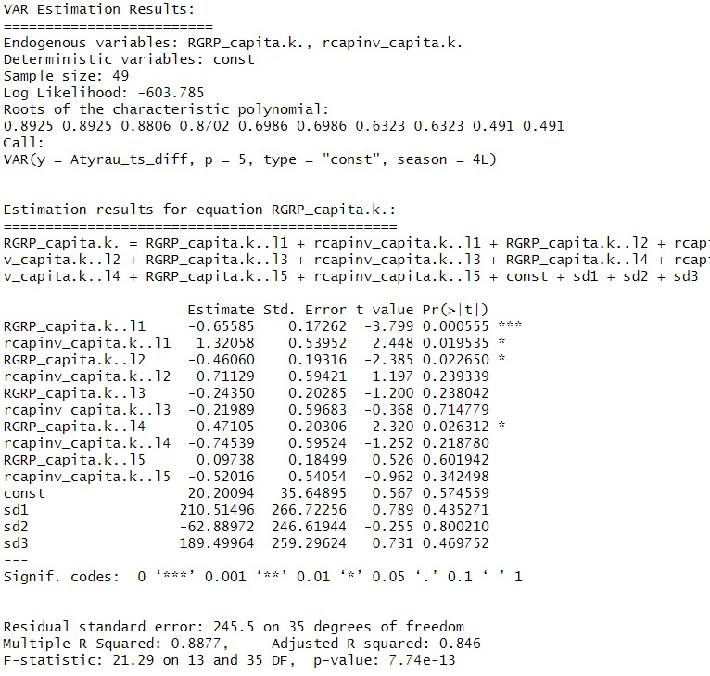
According to these results, several estimated coefficients are statistically significant.
- ‘RGRP_capita.k. l1’: The coefficient is -0.6559, and the p-value is 0.0006. This shows that the real GRP per capita (in thousands of tenge) in the previous quarter has a statistically significant effect on the current quarter’s real GRP per capita. The significance level is 0.1%.

- ‘Rcapinv_capita.k. l1’: Holding other variables constant, a one thousand tenge increase in the change of real capital investment per capita one quarter ago increases the change of real GRP per capita by 1.32 thousand tenge in the current quarter on average. This estimated coefficient is statistically significant at a 5% significance level.

- ‘RGRP_capita.l. l2’: The coefficient for the real GRP per capita (in thousands of tenge) with a two-quarter lag is -0.461 (p-value 0.0227). This indicates that if we hold other variables constant, a thousand tenge increase in the change of RGRP per capita half of year ago decreases the change of RGRP per capita by 0.461 thousand in the current quarter on average. This coefficient is also statistically significant at a 5% significance level.

- ‘RGRP_capita. l4': The estimated coefficient is 0.4711 with a p-value of 0.0263. Controlling for other variables, a one thousand tenge increase in the change of RGRP per capita one year ago leads to a 0.4711 thousand tenge increase in the change of RGRP per capita in the current quarter on average. This coefficient is also significant at a 5% level.

Autocorrelation Function (ACF) and Partial Autocorrelation Function (PACF)
The ACF looks for the correlation between a time series and its own past values at various lags. It identifies trends, seasonality, and the persistence of shocks across time.

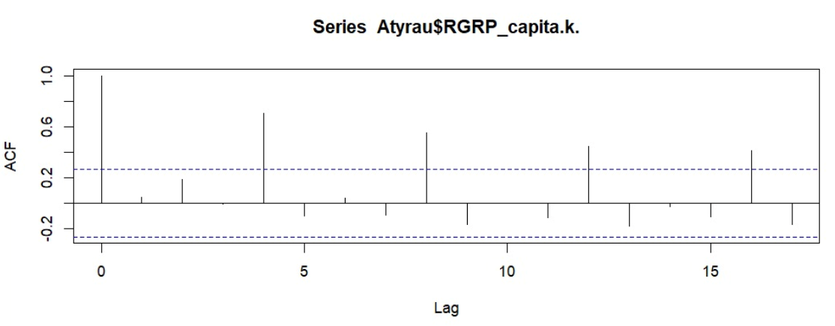
This chart illustrates the Autocorrelation function, showing a distinct possible correlation between the time-specific value of RGRP with the lagged RGRP. The ACF plot demonstrates substantial relationships between every fourth lag (4, 8, 12, …). This means that quarter movements repeat each year.

Forecast of series RGRP per capita

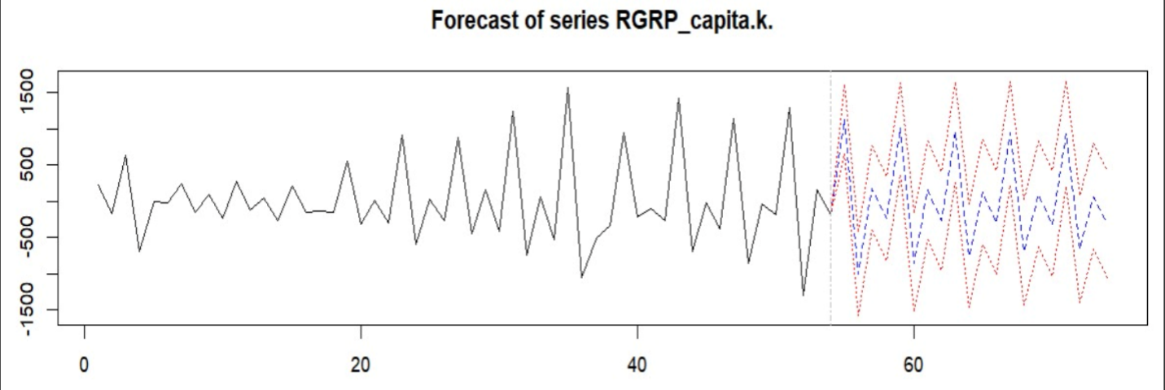
The black line is the historical dynamics of the sample. The red dotted line is the forecast CI (confidence level 95%). The forecast error is expected to be large but stable over time. The blue dotted line is the forecast of the future series ‘RGRP_capita.k.’..
This prediction of Real GRP per capita has a distinct seasonal pattern that corresponds to the series’ dynamics in the sample. It is expected that the change in the RGRP per capita will be negative in the first quarter and turn positive in the second half of the year.

Stationarity and Causality Tests
- Granger Causality Test:

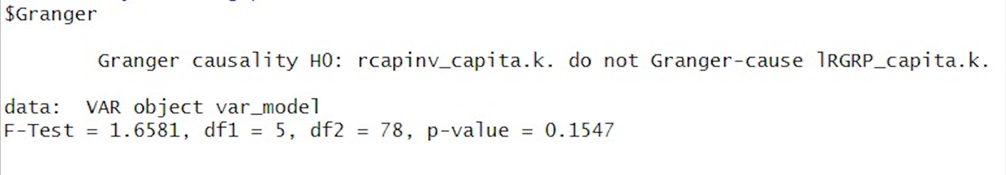
For Karaganda, the p-value obtained was 0.1547. Given that this result exceeds the critical p-value, we fail to reject the null hypothesis at 10% significance levels, indicating that changes in real capital investment and indicators of the past quarter in real capital investment per capita do not significantly predict future changes in real GRP per capita.
- Instantaneous Causality Test:
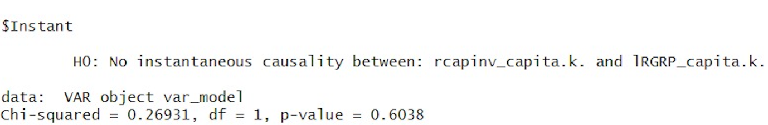
With a p-value of 0.6038, we also do not find evidence of instantaneous causality at a 10% significance level, suggesting that the relationship between real capital investment and RGRP per capita does not have a significant immediate causal link or relationship within the same quarter.
- Augmented Dickey-Fuller (ADF) Test:

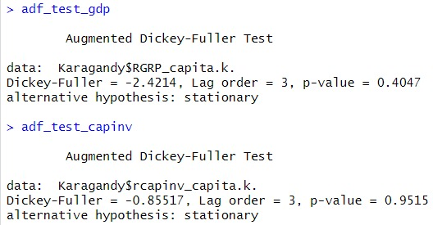
The Augmented Dickey-Fuller test turned up non-stationarity for both variables (p-values for capital investments per capita were 0.9515 and for real GRP per capita were 0.4047). These strong p-values support the existence of unit roots, therefore demonstrating that, in spite of inflation corrections, the series shows seasonal trends or tendencies. To reach stationarity before modeling, thus, differencing is required.

Analysis of Regression Results
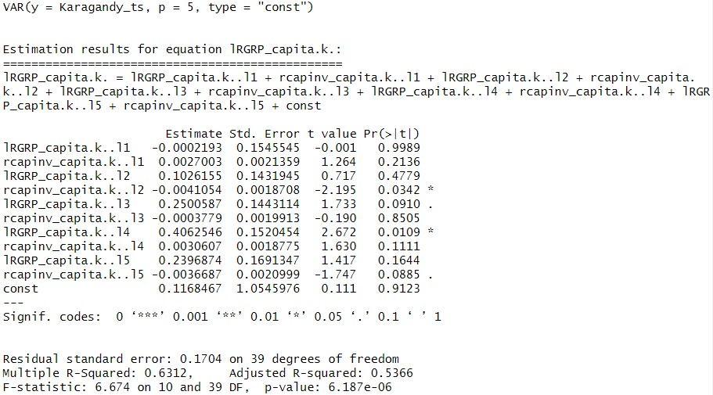
After transforming the series through first differencing, we analyzed the VAR model results.
These estimated coefficients are statistically significant:
- Rcapinv_capita.k.. l2: The coefficient is -0.0041 with a highly significant p-value of 0.0324, indicating that, keeping other variables constant, a one thousand tenge increase in the change in real capital investment per capita a half of year earlier reduces the change in real GRP per capita in the current quarter by a significant estimated coefficient of 4.1 tenge on average. Significance level is 5%

- lRGRP_capita.k.. l3: The coefficient is 0.25(in percentage) with a highly significant p-value of 0.091, indicating that the lRGRP per capita for three quarters ago significantly predicts the current quarter’s value. Significance level is 10%.

- lRGRP_capita.k.. l4: A one per cent increase in the change in real GRP per capita one year ago increases the change in real GRP per capita in the current quarter by 40.6% on average, keeping other variables constant. This coefficient is also statistically significant at the 5% significance level. Since the p-value is 0.011.

- Rcapinv_capita.k.. l5: The p-value is 0.089, indicating that at 10 per cent significance levels the coefficient of -0.0037 is statistically significant. In turn, this means that a one per cent increase in the change in per capita RGDP one year and one quarter ago reduces the change in per capita RGDP by an average of 0.37 per cent in the current quarter, controlling for other variables.

Autocorrelation Function (ACF) and Partial Autocorrelation Function (PACF)

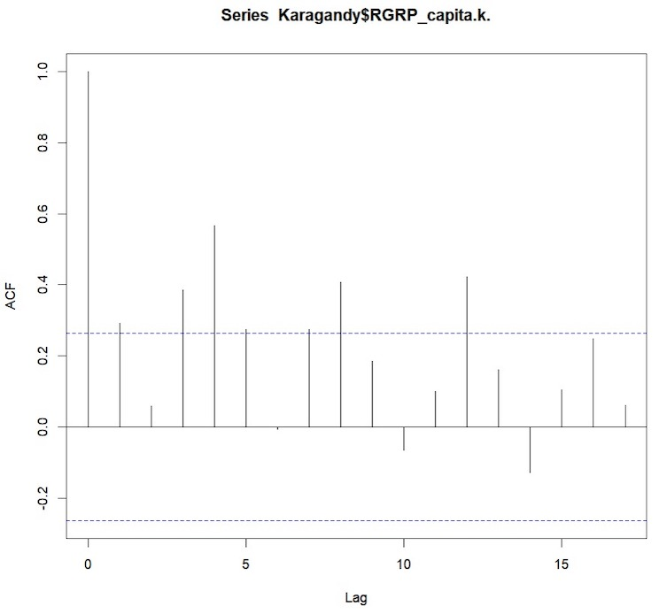
The ACF graph of real GRP per capita in Karaganda shows the same noticeable autocorrelation as in Atyrau, because one can notice a correlation between every fourth lag. In addition, there are significant autocorrelations in the early lags, which emphasise strong dependence from quarter to quarter.

Forecast of series RGRP per capita
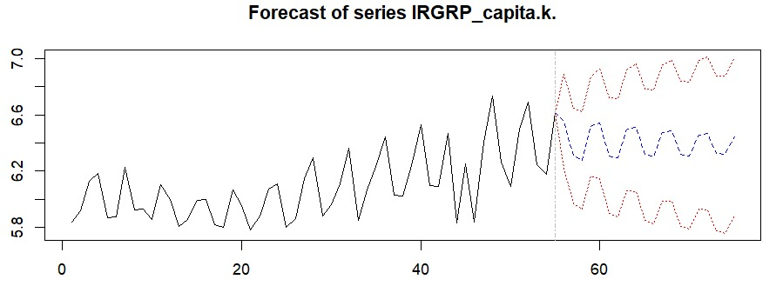
Forecasting the real GRP per capita shows an increased trend continuing throughout the predicted quarters, and larger confidence intervals indicate rising uncertainty over longer horizons.

Key Findings
The ADF tests found that both real GRP and real capital investment per capita had a problem of non-stationarity, due to the existence of seasonal patterns. By applying first differences, we achieved stationarity. Additionally, both regions showed seasonal cycles with significant autocorrelations at every fourth lag.
The Granger causality and instantaneous causality tests in Atyrau revealed a weak but existent causal relationship between real capital investment and real GRP per capita at the 10% significance level. Conversely, for Karaganda, there is no statistically significant causal relationship.
In Atyrau, both the lagged real GRP per capita (lags 1,2, and 4) and the lagged real capital investment per capita (lag 1) had a significant impact on the real GRP per capita growth rate.
In Karaganda, we used the logarithm of real GRP per capita. Statistically significant impacts such as negative effects from lagged changes in capital investment per capita (lags 2 and 5) and positive effects from lagged changes in the log of real GRP per capita (lags 3 and 4). This can be due to the seasonality of the same quarters in two consecutive years. However, the causal link between them is weaker than in Atyrau.
The forecasts for both regions showed a continuation of seasonal patterns observed in the historical data.

CONCLUSION
This study examined how fixed capital investment per capita influences GRP per capita in Kazakhstan. To evaluate infrastructure investment needs across all areas, first we computed the Infrastructure Need Index (INI), a measure incorporating population statistics, fixed assets, and depreciation. Given their high infrastructure investment requirements and great economic potential, we determined Atyrau and Karaganda as priority locations based on the Investment Priority Index (IPI) fluctuations. Applying a Vector Autoregressive (VAR) model, we investigated how previous investments influence future economic performance using quarterly data spanning 2011 to 2024.
For Atyrau, the findings unequivocally revealed a strong predictive link: past capital expenditure greatly affected future GRP increase. Statistically significant coefficients verified that investments in past times favorably affected economic results in next quarters. Thus, maintaining Atyrau's economic development depends on wise investments.
Karagandy, on the other hand, gave different findings. With respect to future GRP per capita at normal significance levels, past capital expenditures showed no evident predictive association. Though sometimes lags revealed important links, generally causation was weaker, implying other economic or structural elements may have more impact on the GRP growth of the region.
Initially showing seasonal trends and non-stationarity, the data of both areas needed changes for correct forecasting. Following data transformation, our projections showed both areas's ongoing increase in GRP per capita, albeit over longer times our estimates became less definite.
This study underlines generally that successful investing strategies depend on an awareness of geographical variations. Customizing policies and investment choices to fit the particular economic situation of every area will help Kazakhstan to achieve far more sustainable development.

REFERENCES
1.Batishcheva G.A. Issledovanie vliyaniya investicij na osnovnye komponenty razvitiya ekonomiki [Study of influence of investments for main components of economy development], Finansovaya analitika: problemy i resheniya [Financial Analytics: Issues and Solutions], 14, 47-50. (2009).[in Russian]

2.Rashidov O.I., Rashidova I.A. Analiz vzaimosvyazi investicij i VRP po oblastyam Central'nogo CHernozem'ya [Analysis of the relationship between investments and GRP in the regions of the Central Black Earth Region], Ekonomicheskie nauki [Economic Sciences), 1 (62), 169-174. (2010). [ in Russian]

3.YAparova -Abdulhalikova G. Investicii v osnovnoj kapital v analize social'no- ekonomicheskogo razvitiya regiona [Investments in Fixed Assets in the Analysis of Socio-Economic Development of the Region], Ekonomika i upravlenie: nauchno- prakticheskij zhurnal [Economics and Management: Scientific and Practical Journal], 4(166), 53-58. (2022). [in Russian]

4. Tishchuk M. O., Naz'mova A. A. Mnogofaktornyj analiz i prognozirovanie investicij v osnovnoj kapital organizacij Kaliningradskoj oblasti [Multifactor analysis and forecasting of investments in the fixed capital of organizations of the Kaliningrad region], Biznes. Obrazovanie. Pravo [Business. Education. Law],1(62), 68-72. (2023) [ in Russian]

5.Rozanova L.I., Moroshkina M.V. Differenciaciya regional'nogo razvitiya i uroven' investicij [Differentiation of regional development and level of investments], Regional'naya ekonomika: teoriya i praktika [Regional Economics: Theory and Practice], 24(303),20-27. (2013) [ in Russian]

6.Korsakova E.A. Sushchnost' i pokazateli ustojchivogo ekonomicheskogo rosta: regional'nyj aspect [Essence and indicators of sustainable economic growth: regional aspect], Vestnik Altajskoj Akademii ekonomiki i prava [Journal of Altai academy of economics and law], 11, 458-463. (2022)) [in Russian]

